**Project Design Phase-II**

**Technology Stack (Architecture & Stack)**

|  |  |
| --- | --- |
| Date | 12th June 2025 |
| Team ID | LTVIP2025TMID28797 |
| Project Name | ServiceNow Cafeteria Menu Display |
| Maximum Marks | 4 Marks |

**Technical Architecture:**

The Deliverable shall include the architectural diagram as below and the information as per the table1 & table 2

**Example: Order processing during pandemics for offline mode**

**Reference: https://docs.servicenow.com/bundle/utah-application-development/page/build/studio/concept/studio.html**

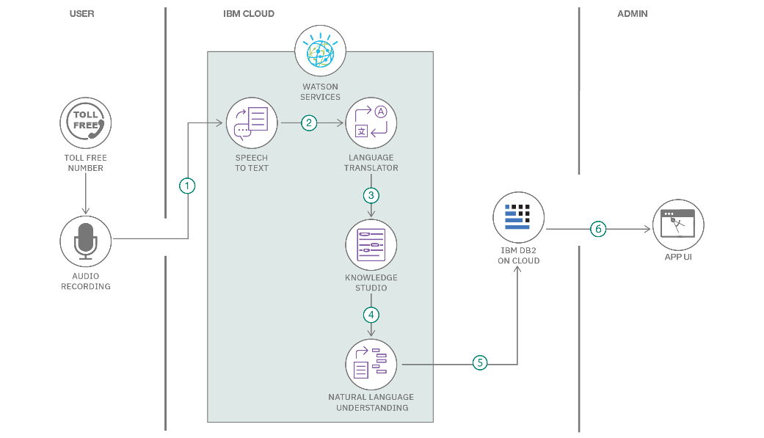

Guidelines:

Include all the processes (As an application logic / Technology Block)

Provide infrastructural demarcation (Local / Cloud)

Indicate external interfaces (third party API’s etc.)

Indicate Data Storage components / services

Indicate interface to machine learning models (if applicable)

**Table-1 : Components & Technologies:**

|  |  |  |  |
| --- | --- | --- | --- |
| **S.No** | **Component** | **Description** | **Technology** |
| 1 | User Interface | Interface to interact with menu submission and display | ServiceNow Web UI |
| 2 | Application Logic-1 | Menu creation, update, publish | JavaScript (within ServiceNow) |
| 3 | Application Logic-2 | Workflow for menu approval and automation | ServiceNow Workflow Editor |
| 4 | Application Logic-3 | Reporting and dashboard logic | ServiceNow Report Builder |
| 5 | Database | Menu table with fields for items, date, status | ServiceNow Tables (internal DB) |
| 6 | Cloud Database | Stored inside cloud-based ServiceNow instance | ServiceNow Cloud |
| 7 | File Storage | No external file storage required | Not applicable |
| 8 | External API-1 | Not used | None |
| 9 | External API-2 | Not used | None |
| 10 | Machine Learning Model | Not used | None |

**Table-2: Application Characteristics:**

| **S.No** | **Characteristics** | **Description** | **Technology** |
| --- | --- | --- | --- |
|  | Open-Source Frameworks | List the open-source frameworks used | Technology of Opensource framework |
|  | Security Implementations | List all the security / access controls implemented, use of firewalls etc. | e.g. SHA-256, Encryptions, IAM Controls, OWASP etc. |
|  | Scalable Architecture | Justify the scalability of architecture (3 – tier, Micro-services) | Technology used |
|  | Availability | Justify the availability of application (e.g. use of load balancers, distributed servers etc.) | Technology used |
|  | Performance | Design consideration for the performance of the application (number of requests per sec, use of Cache, use of CDN’s) etc. | Technology used |

**References:**

**🔗** [**https://docs.servicenow.com/bundle/utah-application-development/page/build/studio/concept/studio.html**](https://docs.servicenow.com/bundle/utah-application-development/page/build/studio/concept/studio.html) **🔗** [**https://docs.servicenow.com/bundle/utah-application-development/page/build/studio/concept/studio.html**](https://docs.servicenow.com/bundle/utah-application-development/page/build/studio/concept/studio.html) **🔗** [**https://docs.servicenow.com/bundle/utah-platform-administration/page/administer/table-administration/concept/c_TableOverview.html**](https://docs.servicenow.com/bundle/utah-platform-administration/page/administer/table-administration/concept/c_TableOverview.html)